5.PROJECT DEVELOPMENT PHASE
Project Title:
Implement Client Script & UI Policy (Incident)
1. Introduction
The development phase involves implementing UI Policies and Client Scripts in the Incident table of ServiceNow. These configurations help automate field behavior, validate user inputs, and improve data accuracy.
2. UI Policy Creation
A UI Policy was created to control the behavior of fields in the Incident form based on user input conditions.
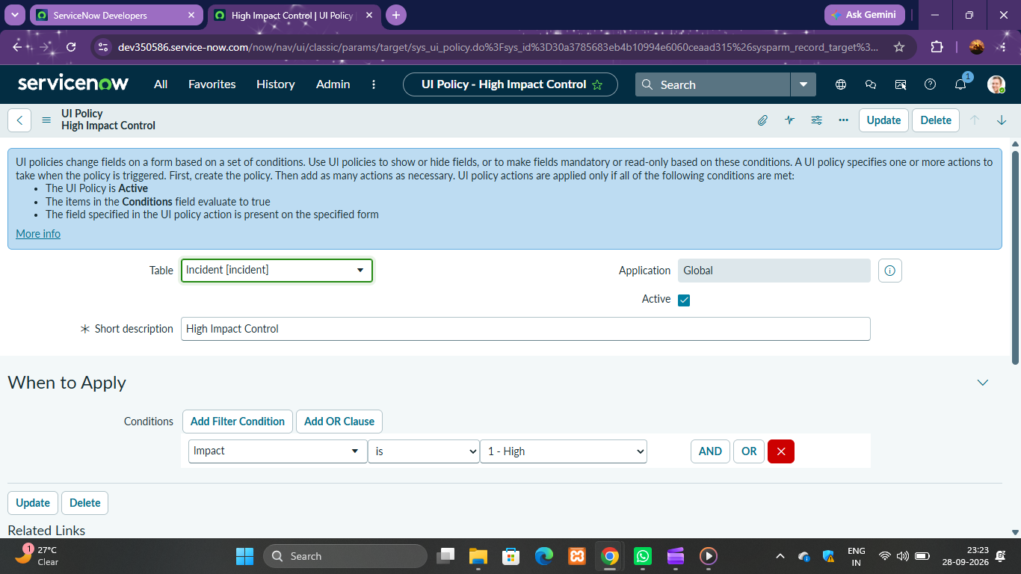
3. UI Policy Action
UI Policy Actions were configured to make fields mandatory, read-only, or visible according to the defined conditions.
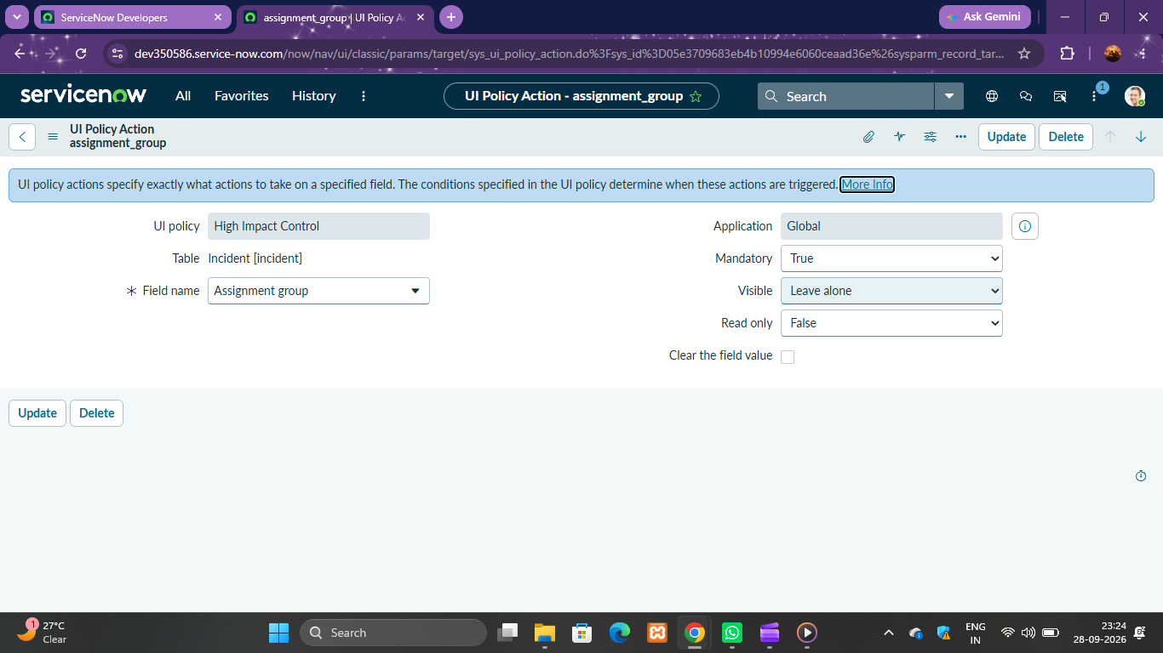

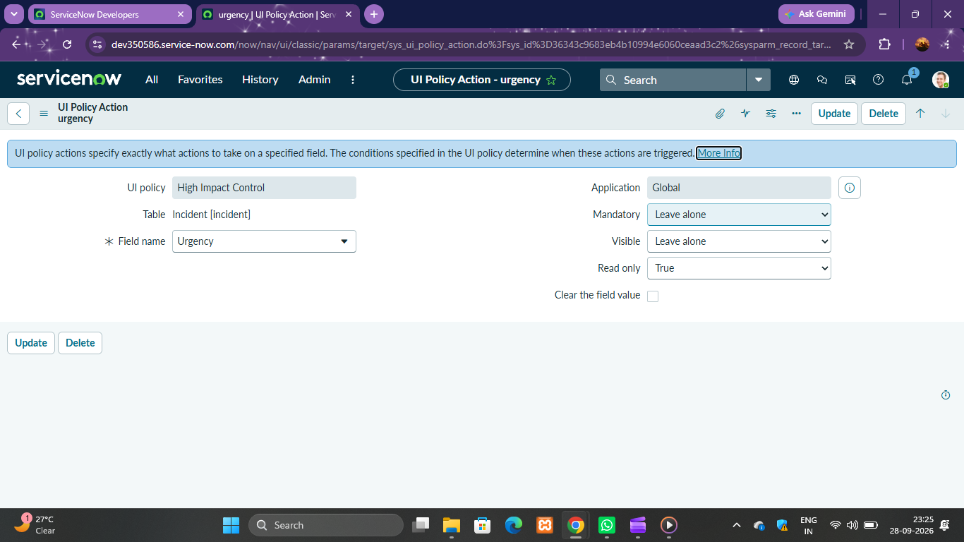
4. onChange Client Script
An onChange Client Script was created to automatically respond when a field value changes.
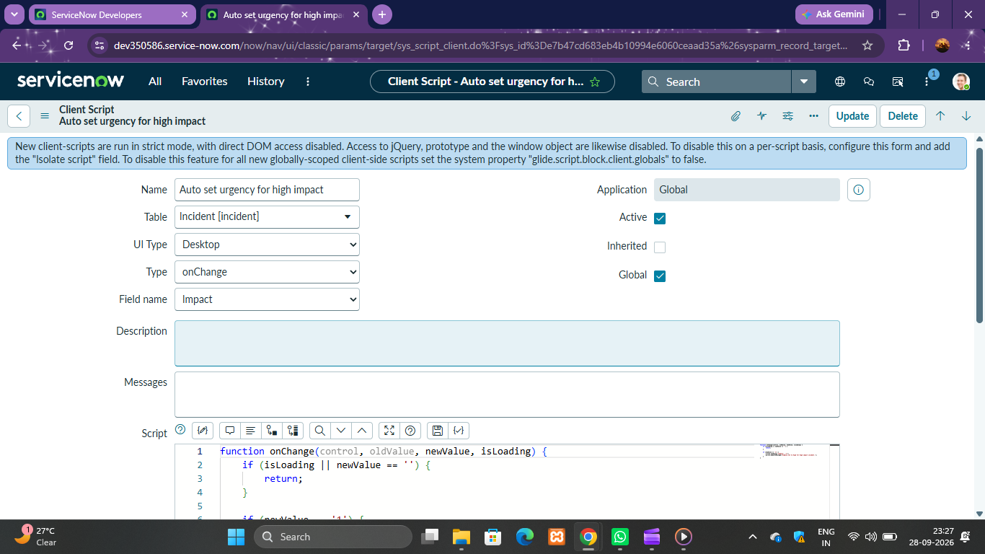

5. onSubmit Client Script
An onSubmit Client Script was implemented to validate the form before submission.
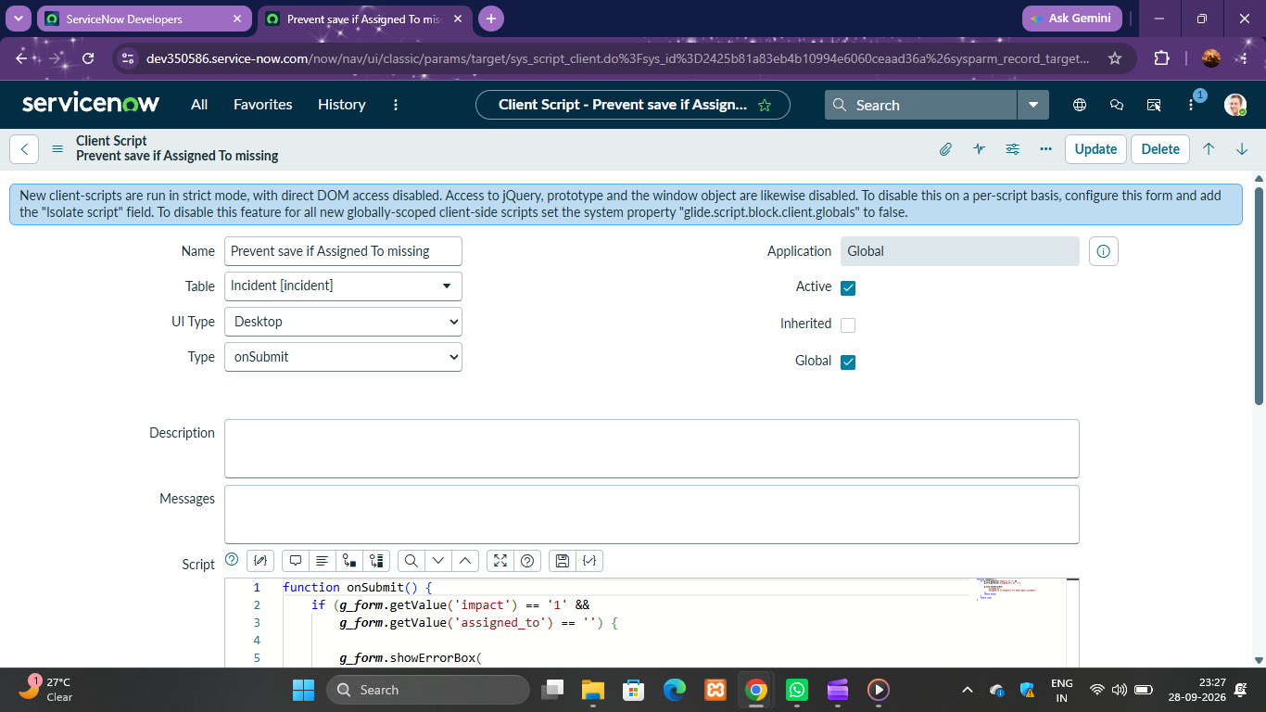

6. onCellEdit Client Script
An onCellEdit Client Script was created to validate data when a field is edited in a list view.
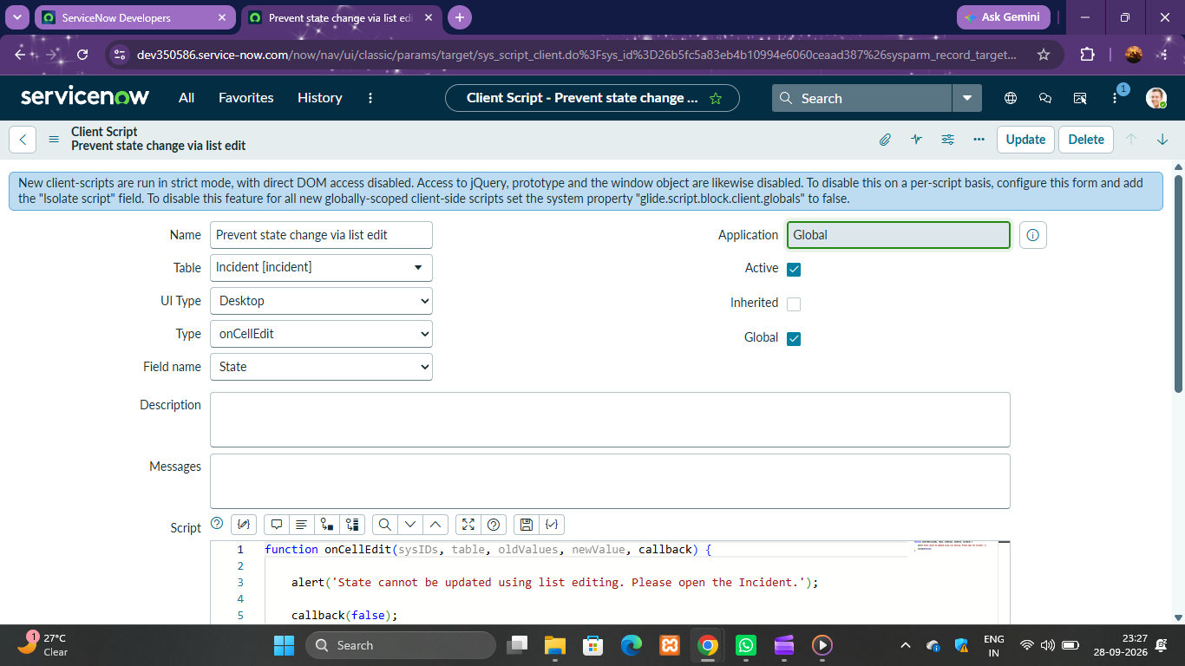

7. Development Outcome
The Incident form was successfully enhanced using UI Policies and Client Scripts. The implementation improved form validation, reduced manual errors, and ensured better data consistency.

